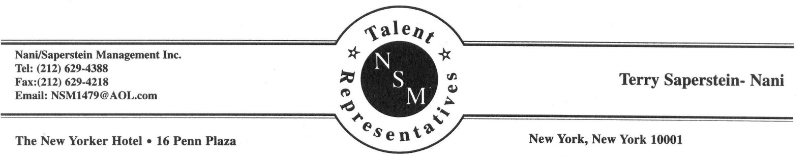

JARED BRADSHAW

AEA

Height: 6’0" Hair: Brown Eyes: Blue www.jaredbradshaw.com

**BROADWAY:**

**Jersey Boys**, August Wilson Theatre Swing: Tommy Devito Director: Des McAnuff

Jersey Boys, 1st National Tour Nick Massi, Bob Crewe Choreo: Sergio Trujillo

Jersey Boys, Chicago Norm, Gyp, Hank, Barry

**OFF BROADWAY / NEW YORK THEATRE:**

Forbidden Broadway: Goes to Rehab; SVU Performer Directors: Gerard Alessandrini & Philip George

Forbidden Broadway: Rude Awakening (CD) Performer Directors: Gerard Alessandrini & Philip George

Dr. Sex @ Peter Norton Space George, Dr. Kinsey u/s Directors: Pam Hunt, Ethan McSweeney

Choreo: Mark Esposito, Mus. Dir.: Patrick Vaccariello

The Talk of the Town @ The Algonquin Robert Benchley Directors: Dan Wackerman & Mercedes Ellington

Love Comics, by David Evans w/York Theatre Kyle Director: Pamela Hunt 108 Waverly w/Amas Music Theatre Brian Directors: Sam Viverito **&** Aja Kane

Putting It Together @ The Emelin Theater The Observer Director: Brett Smock

Torched @ Downtown Urban Theater Fest. Mr. Lovestruck Director: Gerald Vanderheen

Hidden Voices Lead Director: Terrence Mann

@ Minetta Lane Theatre Choreo: Christopher d'Amboise

The Great Railroad Race Jake Director: Michael Scheman

@ "Theaterworks USA" Choreo: Cindy Thole

Judy Garland & Uninvited Company @ Danny’s Skylight Room Director: Donna Drake

**REGIONAL:**

The Music Man Harold Hill Director: Terrence Mann

The Last 5 Years Jamie Director: Dennis Courtney

My Way- A Musical Tribute to Frank Sinatra Man #1 Director Kate Swan

Cabaret Cliff Bradshaw Director: Dom Ruggiero

Smokey Joe's Café (3 productions) The White Guy Director: Donna Drake, Jill Carlen, Cate Caplin

The Music Man Harold Hill Director: Terrence Mann

Cruisin’ Classics: A Night At The Diner Singer Director: Rob Asselstine

Gateway Holiday Spectacular - Gateway Playhouse Director DJ Salisbury

West Side Story Riff Choreo: Megan McNulty

Return to the Forbidden Planet Captain Tempest Director: Robert Chapel

The All Night Strut The White Guy Director: Cate Caplin

You’re a Good Man Charlie Brown Snoopy Director: Robert Chapel

Jekyll and Hyde Jekyll/Hyde Director: Tom Hollis

Singin' in the Rain Don Lockwood Director: Jamey Varnadore

**OTHER THEATRE & CRUISES:**

Oklahoma! Curly Director: Tom Kidd

Pirates of Penzance Pirate King Director: Tom Kidd

Little Shop of Horrors Orin Scrivello Director: Tom Kidd

The Fantasticks El Gallo Director: David Kleist

A Funny Thing…Forum Hero Director: Greg Payne

Guys and Dolls Benny Southstreet Director: Kathy Newman

Grease Roger Director: Ron Hubbard

Hercules: The Muse-ical Phil Director: Claude Smith III

Disney Dreams King Choreo: Ed Whitlow

Voyage of the Ghost Ship Dutch Choreo: Ed Whitlow

Who Wants to Be A Mouseketeer? Game Show Host

**LIVE INDUSTRIALS:**

Big Top Blast Off Melvin The Boulevard, Las Vegas, NV

Einstein's Science Spectacular Maddy Dir: Anthony Glade, Allian Productions

**TRAINING:**

Degree: BFA Musical Theatre, Shorter College; Rome, GA

Voice: Dr. John Thomasson, 4 years, Eleanor Harwell, 2 years; Workshop : Joan Lader, Liz Caplan

Acting: Tom Kidd, Ron Hubbard, Kathy Newman, David Kleist, Greg Payne, Anita Stroup

Dance: Jazz, Tap, Ballet, Modern: 4 years Georgie Hall; Donna Stephens, 2 years

**SKILLS:**

Stage Combat, Spanish, Puppetry, Rollerskate/blading, soccer, sight reading, a capella group harmony, dialects, character voices, falsetto